'Gathering' Web Site



User Guide

(Version 1)

Index

**Chapter 1 - First time to use website 3**

Registration3

Change password4

Forgot password5

Define yourself6

**Chapter 2 - Make friends and create event7**

How to make friends and delete friends?7

What is 'No show'?8

How to create event?9

**Chapter 1- First time to use website**

Registration

If this is the first time to use this web site, you should become our member first.

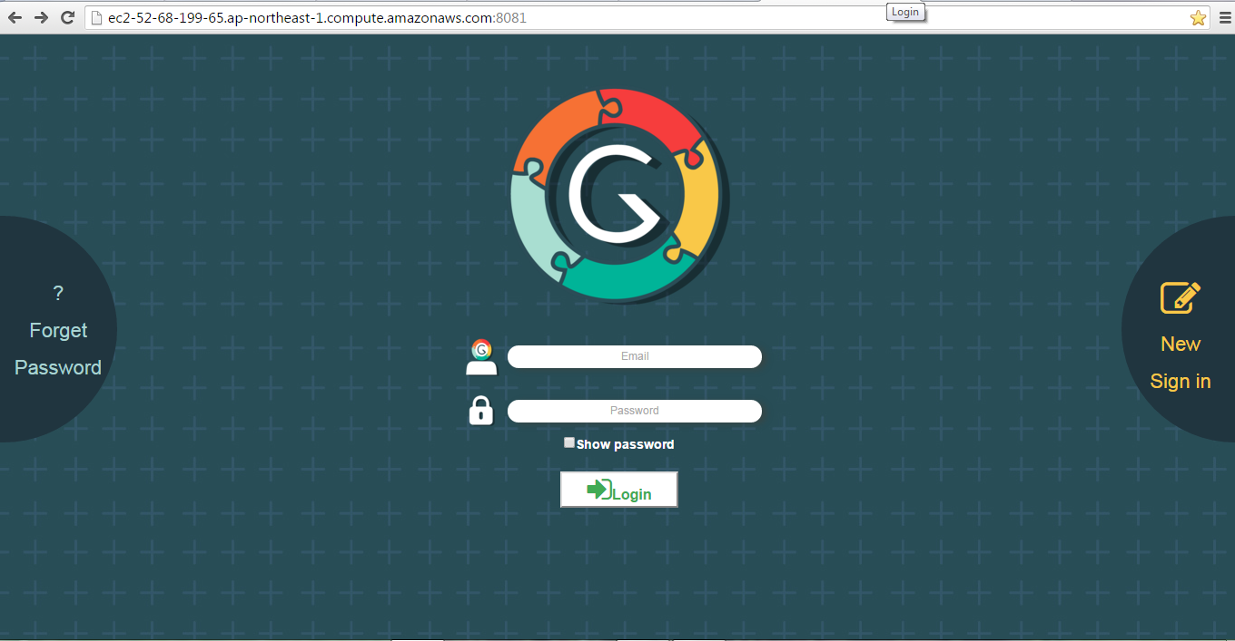

After that, type your e-mail address in the box and click 'submit'

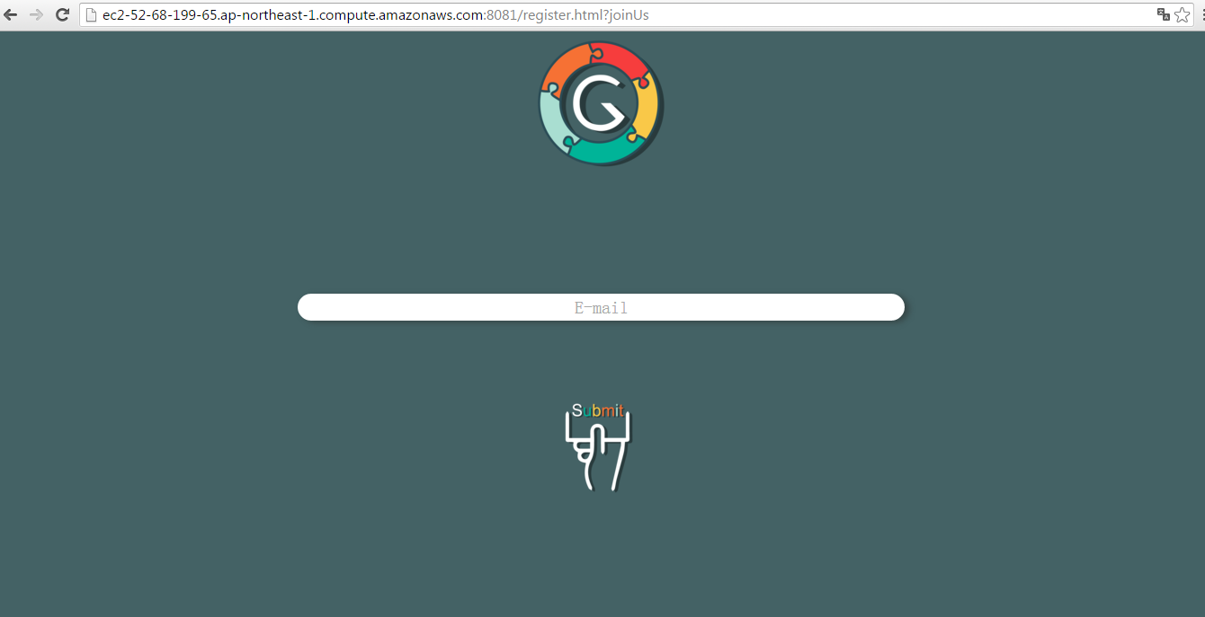

Go to your mail box and you will see a new mail which is sent by our website. And you will a password in the mail content. Please use this password to login our website.

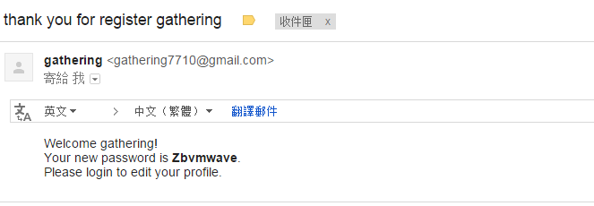

Change password

After you login our website, you must change your password first.

**Click Setting -> Change password -> Input your current password ->**

**Input your new password twice(minimum to 8 characters, maximum to 16 characters)**

**-> Click Save**

If it is success



If the new password is fail



Forget password

If you forgot your password, please click 'Forget Password'.



Click this

Furthermore, type your email address and click 'Submit'. If it is success, it will show



And we will give you a new password to you. You just use this password to login and change to your own password.

Define yourself

Set your nick name and profile picture are important because these can help your friends to find you easily.

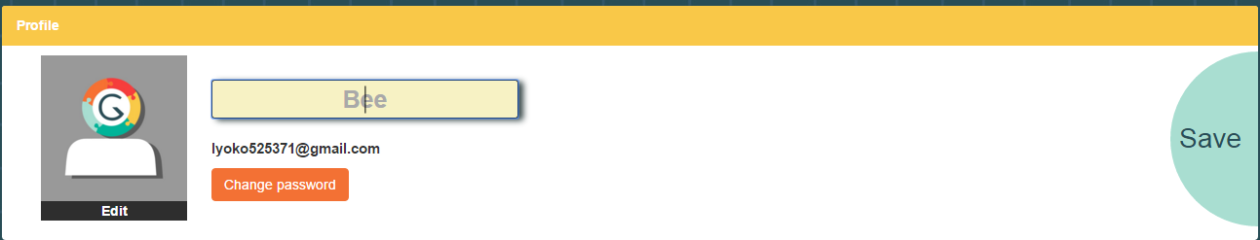

Set your nick name: Just type your nick name in the text box (red circle) and click 'save'

Set your profile picture: Click 'Edit' -> Choose your photo

-> Adjust your photo size , you can use the '-' and '+' to zoom in or zoom out of your photo

-> Click crop if you finished to adjust

(The square box is the fixed size because the profile picture can just show in this size)

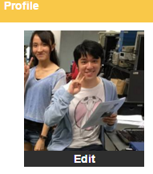

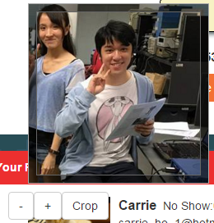

**Chapter 2- Make friends and create event**

How to make friends and delete friends ?

It is really easy to make friends. Just add your friends in your friend list. First of all, please input your friends nick name in 'search box' which is on top of the website. For example, I type 'Jeff' in search box and click the search icon. You will see all the member who are the nick name have 'Jeff' in search friend list. If you can see some friends that you want to add, just click the '+Friend'. After that, you will see your friend in your friend list. In search friend list and your own friend list, you also can press 'unFriend' to delete your friend. If you do this action, you can't invite the friend which you have delete until you find and press '+Friend' to him or her again.

Input your friends nick name in 'search box'

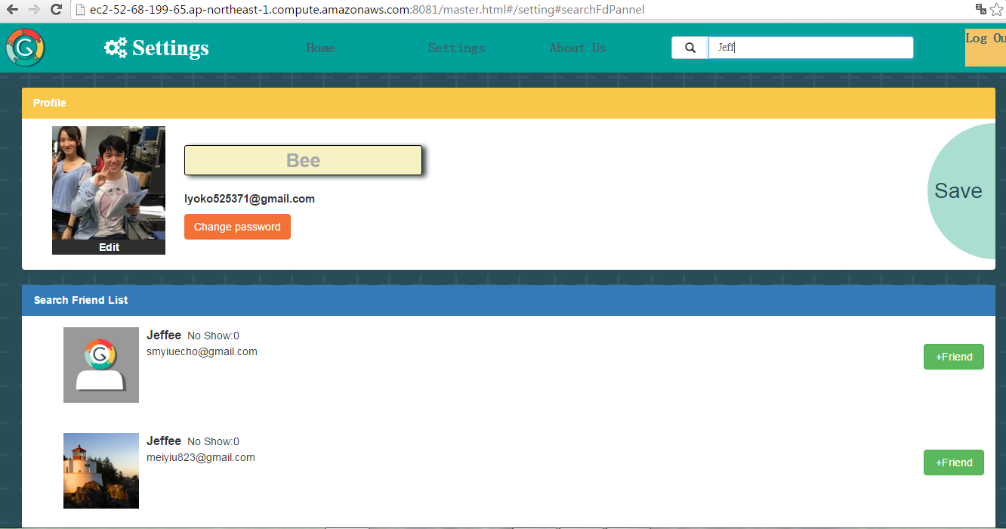

Add the friend in your friend list

Show the member who have 'Jeff' in their nick name

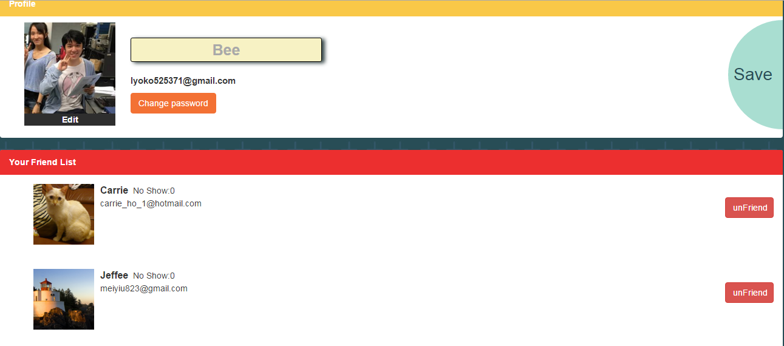

Delete your friend

What is 'No Show' ?

If you see your friend list, you will discover 'No show: 0' near your friend profile picture.

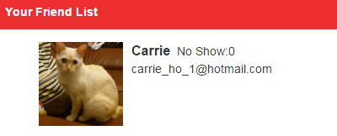

'No show' function is used to count and show how many times that your friend didn't vote in your previous events. The reason of create this function is there are many people don't response the invitations. This is so annoy to the inviters. Therefore, this function is help the inviters to know who are active to join the events and who are always ignore the invitation. It helps the inviters to choice their member in next event.

How to create event?

First of all, you will see this circle in home page. Then click 'Create Gathering'.

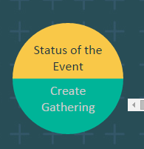

After that, you will see the following page.

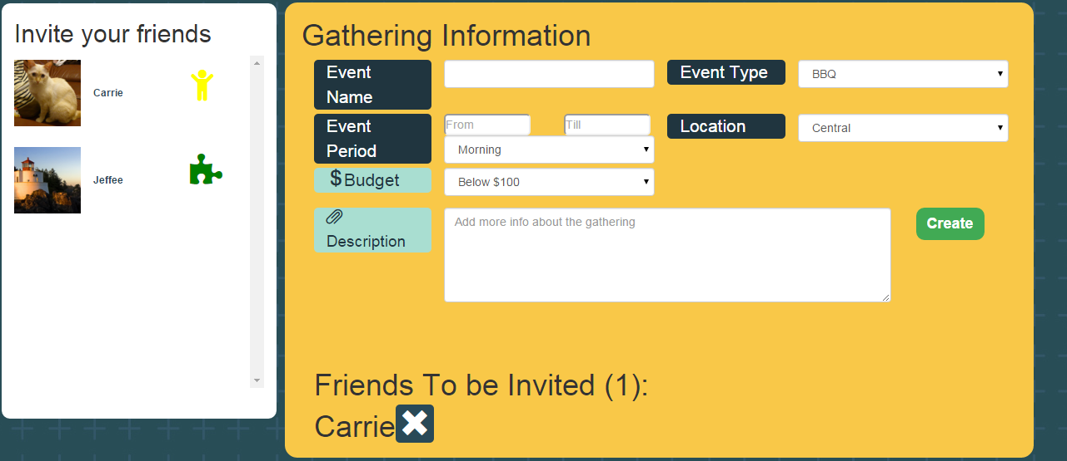

This page can separate in red part and blue part.

Blue part: This part is used to show your friend list. After you click the puzzle icon, the friends who are invited will show in 'Friends To be Invited'.

Red part: This part is used to define your event.

Event name: Use to define the event name

Event type: Define what you want to do in this event and there are some choices that allow you to choose

Event period: The time period that allow the member to choose

Location: Define where you want to go in this event

Budget: Define the budget of this event

Description: Write something that you need to mention

So after finish to set the details of event, click 'create'. Then, you will see your event in Home page.

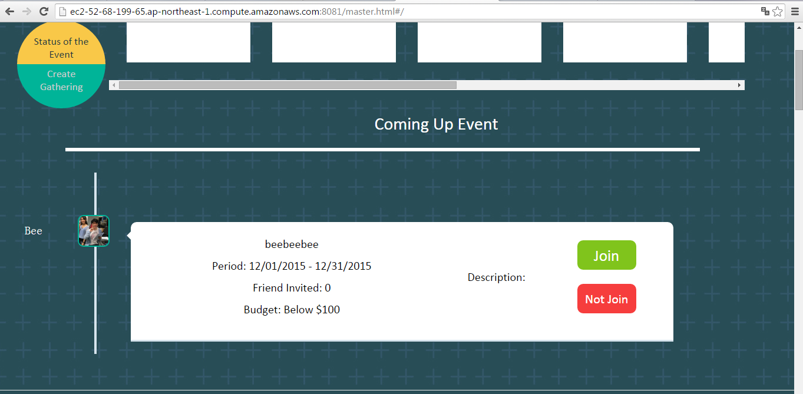

And the friends who are invited by you can press 'Join' and 'Not Join'. If someone choose join, he or she can vote or give some suggestions of this event.